# Lab: CSS Selectors and Rules

Problems for exercises and homework for the “HTML and CSS” course @ SoftUni. Submit your solutions in the SoftUni judge system at <https://judge.softuni.bg/Contests/404/Lab-CSS-Selectors-and-Rules>.

## Photo Shoot Effect

Create a Web Page like the following using "**photo-shoot-effect.html**"

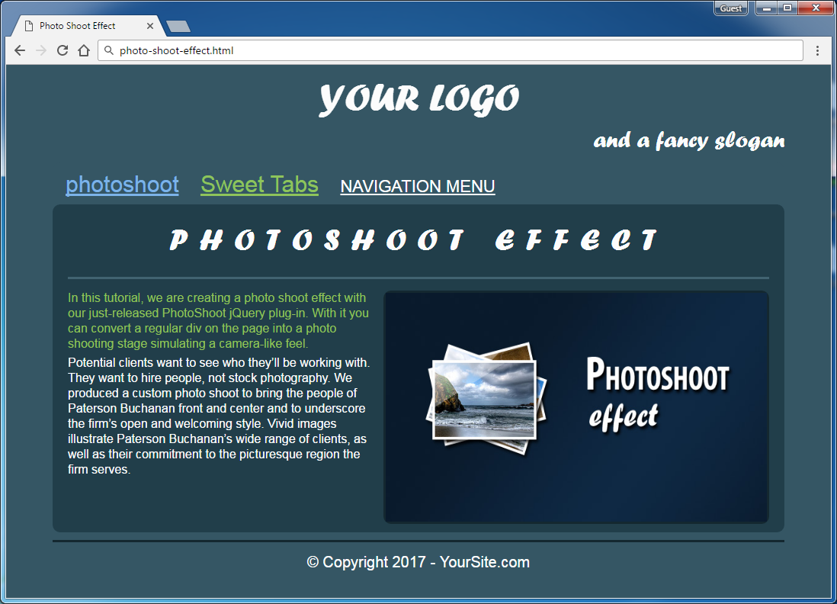

Create file: "**photo-shoot-effect.css**"

You are **NOT** allowed to change the html file.

### Constrains

* **<body>**
  + Width: **960px;**
  + Center the body
  + font-family: **Arial, sans-serif;**
  + Text Color: **#fcfcfc**
  + Background: **#355664;**
* **Headings**
  + Font-family: forte, Arial, sans-serif;
* <h1>
  + Text size: **50px**
  + Padding: **10px 0 0;**
  + Center the text
* <h2>
  + Text size: **40px;**
  + Letter spacing: **15px**
  + Center the text
  + Border at the bottom: **3px solid #416371**
  + Padding at the bottom: **20px;**
* <h3>
  + Text Align: **right;**
  + Text size: **30px;**
  + Font-weight: **normal;**
  + Margin: **0 0 10px;**
* **Paragraphs**
  + Line height: **20px**
  + Padding bottom: **5px;**
  + Text Color: **#94c258;**
* **Images**
  + Width: **500px;**
  + Height: **300px;**
  + Border: **None;**
* Div with class = "**article-content**"
  + Margin: **15px 0;**
* **Navigation**
  + Background: **#355664;**
  + Padding-right and Left: **5px**
  + Padding-top and Bottom: **0px**
* **Hyperlinks**
  + Text Color: **#ffffff**
  + **Text Color: #7CB3E9**
  + **Text Color: #8EC45B**
  + **Margin: 5px 2px;**
  + **Padding: 7px 10px 4px;**
  + **Text Size: 30px;**
* **Article**
  + Height: **390px;**
  + Background: **#213E4A**
  + Padding: **20px**
  + Margin: **0 0 10px;**
* **Figure**
  + Border: **3px solid #142830;**
  + Float: **right;**
  + Height: **300px;**
  + Width: **500px;**
  + Marginleft: **15px;**
* **Footer**
  + Border at top: **3px solid #142830;**
  + PaddingTop: **15px;**
  + MarginBottom: **30px;**
  + Centerthetext
  + Textsize: **20px;**

### Hints

Use:

* Reset the CSS file;
* text-transform: **uppercase;**
* text-transform: **none;**
* text-transform: **lowercase;**
* border-radius: **10px;**

## Ancient Architecture

Create a Web Page like the following using"**ancient-architecture.html**".

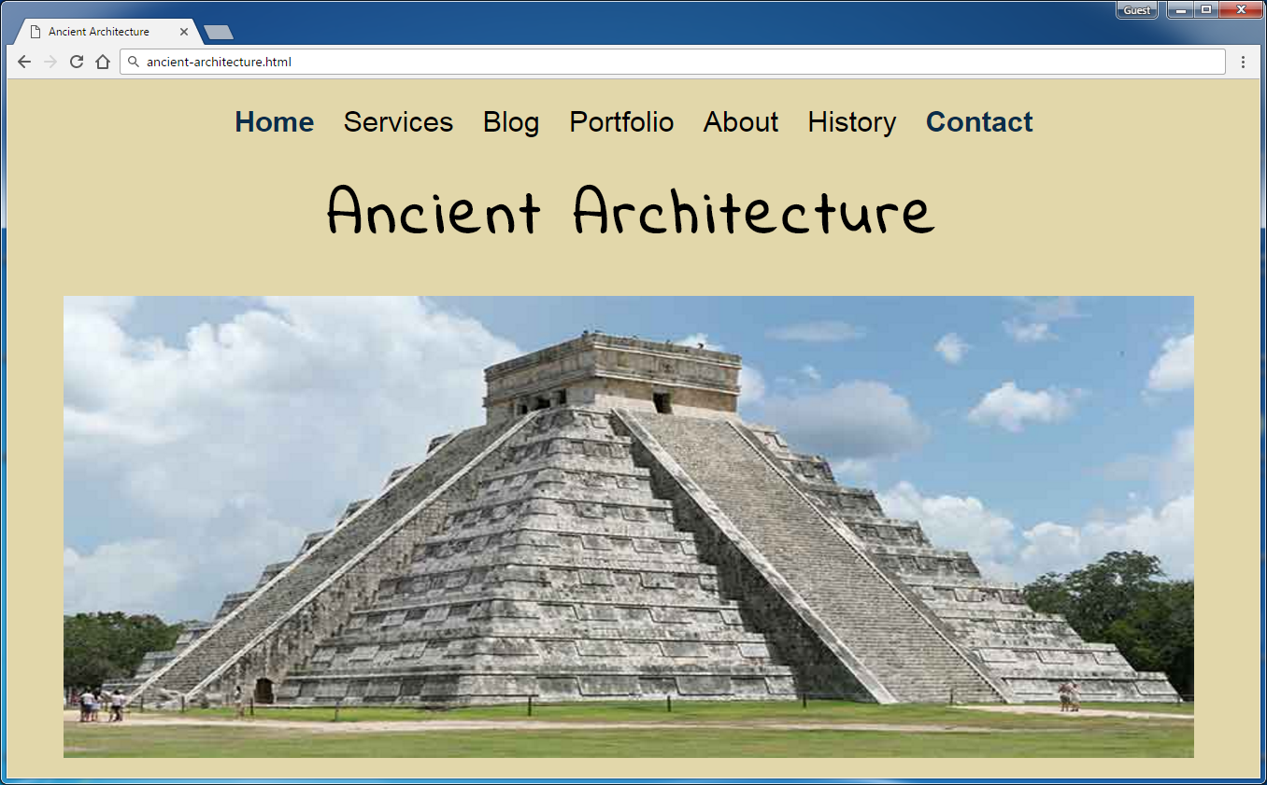

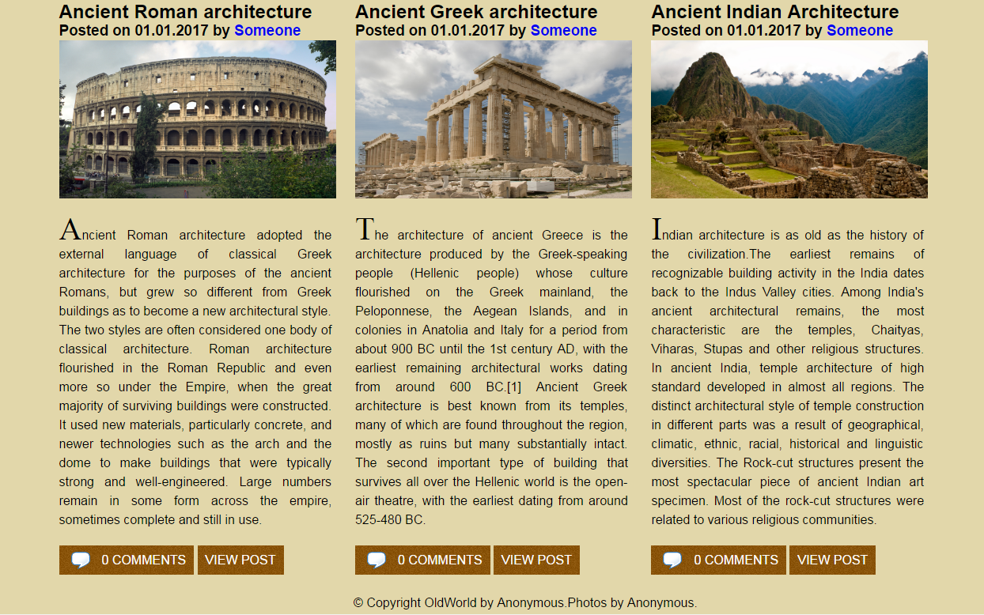

Create file: "**ancient-architecture.css**"

You are **NOT** allowed to change the html file.

Font-family: **Roboto, sans-serif; 'Indie Flower', cursive; EucrosiaUPC sans-serif;**

### Constrains

* **Body**
  + Font Family: **Roboto, sans-serif;**
  + Background:#e2d7aa;
  + Text Color:#000000
  + Text size: 16px
  + Width:1180px;
  + Center the **container**
* **Image**
  + Width: **1100px;**
  + Height: **450px;**
* **Image-container**
  + Width: **1600px;**
  + Height: **450px;**
  + Margin at Top: **65px;**
* **<h1>**
  + Text size: **60px;**
  + Center the text
  + Margin at the top: **65px**
* **Navigation**
  + Margin: **30px**
* **Hyperlinks**
  + Text size: **28px**
  + Text-color: **#000000;**
* **Hyperlink**
  + Text-color:#0a2d4a;
  + Font Weight: **Bold**
* **Image** inArticle
  + Width:350px;
  + Height: **200px;**
  + Margin Bottom:20px;
* **First Letter in paragraph**
  + font-family: **EucrosiaUPC sans-serif;**
  + Text size: 40px;
* **Hyperlink in span**
  + Background: **url(images/bg2.jpg)**
  + Textcolor:#ffffff;
  + Padding 10px
  + Margin-top: 10px
* **Footer**
  + Margin: 0px
  + Padding: 40px 0 64px 0
  + Center the text

### Hints

To style the comments box use:

**article p:last-of-type span:first-of-type a::before** {

content: url("images/comment.png");

position: relative;

right: 5px;

top: 7px;

}

## Coffee Home

Create a Web Page like the following using the HTML from the file "**coffee-home.html**". Write the missing CSS.

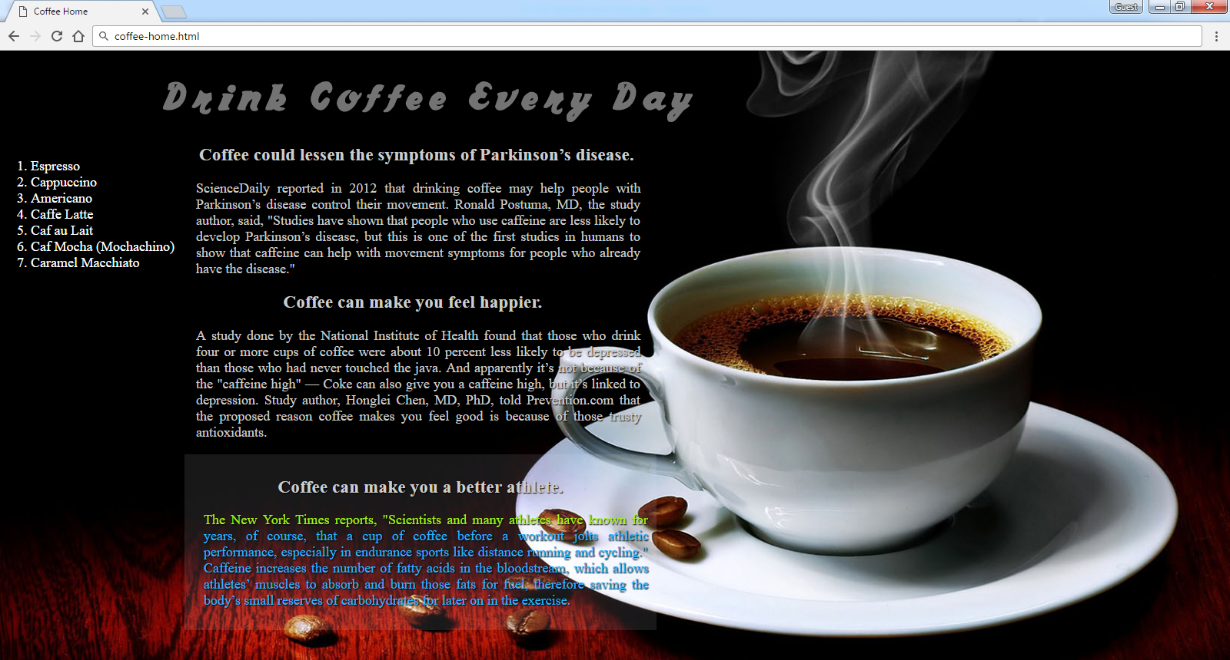

Create file: "**coffee-home.css**"

You are **NOT** allowed to change the HTML file.

Default font: **"Times New Roman", serif**

Default color: **#ffffff**

Font: **coffee**

Colors: **#737373, #CCCCCC, #22b6fd, #a6f016**

### Constrains

* Default font-size: **18px**

### Hints

Use:

* Define the “font-size” using rem